March 3, 2022

Editors of Science
Science
1200 New York Avenue NW
Washington, DC 20005

Editors of Science,

Please consider my paper with Jeanie Santaularia and Christopher Uggen, “Temporal and Spatial Shifts in Gun Violence, Before and After a Historic Police Killing in Minneapolis” for publication in Science.

Please contact me if you would like any additional information or if I can be of any other assistance. I am most easily reached at the electronic mail address below. Thank you for your consideration. I look forward to hearing from you and the reviewers.

Sincerely,
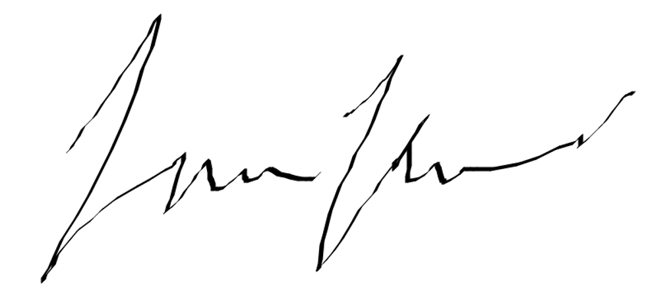
Ryan Larson
Ph.D. Candidate
Department of Sociology, University of Minnesota
lars3965@umn.edu | (218) 244-7188

